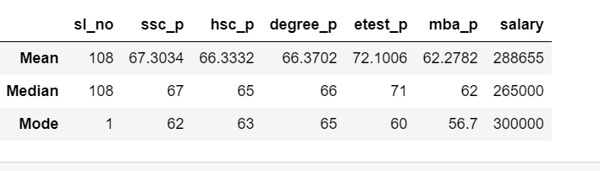

The **"mean"** is a measure of central tendency in a dataset. The mean is a way to find the average of a group of numbers. By adding up the numbers and then divide the total by how many numbers there are.

The **“median”** is the middle value in a set of data .By arrange the data in numerical order from smallest to largest .  
If there is an odd number of data points, the median is the middle value.  
If there is an even number of data points, the median is the average of the two middle values.

The **"mode"** is the value that appears most frequently in a set of data.

|  |
| --- |
|  |
| **The key takeaways from this analysis:-** |

**Secondary Education Percentage (ssc_p):**On average, candidates in the dataset had a mean SSC percentage of approximately 67.30. This suggests that most individuals had reasonably good scores in their secondary education.

**Higher Secondary Education Percentage (hsc_p):**

The mean HSC percentage was about 66.33, indicating that candidates maintained a consistent level of performance in their higher secondary education.

**Undergraduate Degree Percentage (degree_p):**  
The average degree percentage was approximately 66.37. This suggests that, on average, candidates performed at a similar level in their undergraduate degree programs.

**E-Test/Entry Percentage (etest_p):**  
The mean E-Test percentage was relatively higher, at around 72.10. This could indicate that the candidates performed better in this particular test.

**MBA Percentage (mba_p):**  
The average MBA percentage was about 62.28. This suggests that candidates achieved varying scores in their MBA programs.

**Salary:**  
  
The mean salary in the dataset was 288,655, with a median salary of 265,000 and 300,000 is the most common salary level. This reflects the overall distribution of salary levels, with some candidates earning significantly higher salaries.